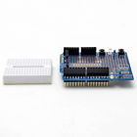A**rduino Prototyping Prototype Shield ProtoShield With Mini Breadboard**

* 100% brand new and high quality
* Prototype Size:7cm x 5.4cm x 1.8cm
* Mini breadboard size: 4.4 x3.4 x1cm
* Quantity:1pc
* The breadboard sticks on the prototype shield with its self-adhesive backing
* Small soldering area
* The mini breadboard has 170 tie points
* SOIC place for IC
* 1 reset button, 1 general use button, and 2 LED circuits can be used directly

Package Included:

* 1PCS*Arduino Prototyping Prototype Shield ProtoShield Board
* 1PCS* Mini Breadboard 170 Points

Was Expecting this:

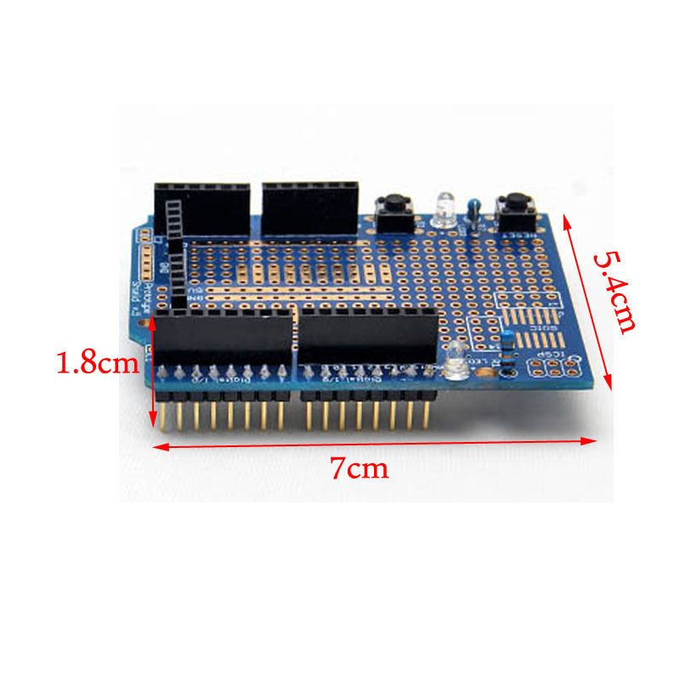

Got This:

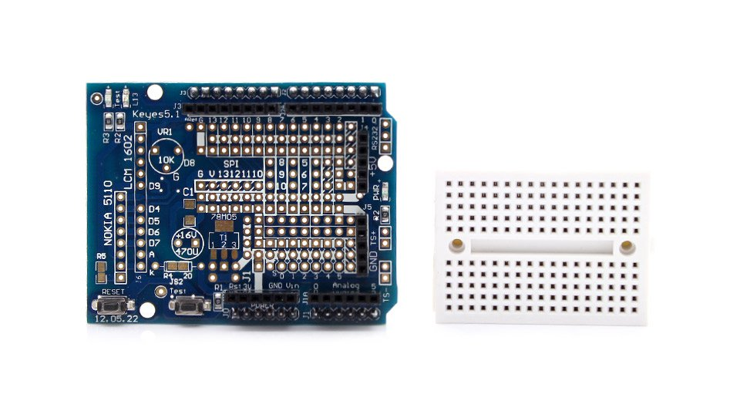

(Information about the Proto-Shield with Nokia 5110/LCM 1602 Headers)

<http://www.fasttech.com/product/1115500-arduino-compatible-prototype-proto-shield>

<http://arduino-for-beginners.blogspot.com/2010/11/arduino-protoshield-mini-breadboard.html>